**WHITE WATER RAFTING SITE PLAN**

**1. Logo.**

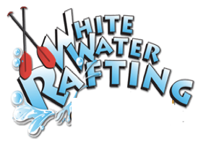

**2. Color Palette:**

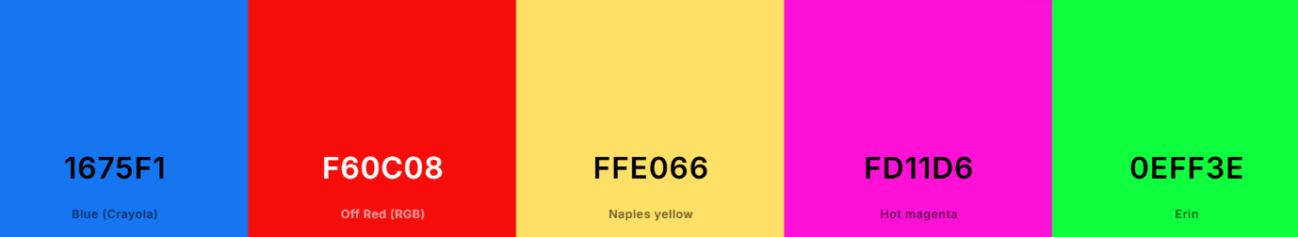

primary-color: #1675F1

secondary-color: #F60C08

accent1-color: #FFE066

accent2-color: #FD11D6

3**. Fonts:**

heading-font: Winky Rough

text-font: Nunito sans

4. **Color Palette URL:**

https://coolors.co/1675f1-f60c08-ffe066-fd11d6-0eff3e